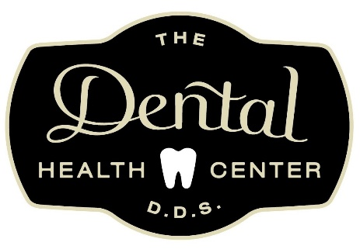
COVID-19 PANDEMIC DENTAL TREATMENT
NOTICE AND ACKNOWLEDGEMENT OF RISK FORM

Our goal is to provide a safe environment for our patients and staff, and to advance the safety of our local community. This document provides information we ask you to acknowledge and understand regarding COVID-19.

COVID-19 is a serious and highly contagious disease. The World Health Organization has classified it as a pandemic. You could contract COVlD-19 from a variety of sources. Our practice wants to ensure you are aware of the additional risks of contracting COVlD-19 associated with dental care.

COVlD-19 has a long incubation period. You or your healthcare providers may have the virus and not show symptoms and yet still be highly contagious. Determining who is infected by COVlD-19 is challenging and complicated due to limited availability for virus testing.

Due to the frequency and timing of visits by other dental patients, the characteristics of the virus, and the characteristics of dental procedures, there is an elevated risk of you contracting the virus simply by being in a dental office.

Dental procedures create water spray which is one way the disease is spread. The ultra-fine nature of the water spray can linger in the air for a long time, allowing for transmission of the COVlD-19 virus to those nearby.

You cannot wear a protective mask over your mouth to prevent infection during treatment as your health care providers need access to your mouth to render care. This leaves you vulnerable to COVlD-19 transmission while receiving dental treatment.

I confirm that l have read this notice and understand and accept that there is an increased risk of contracting COVlD-19 in a dental office or with dental treatment. I understand and accept the additional risk of contracting COVlD-19 from contact at this office. I also acknowledge that I could contract COVlD-19 from outside this office and unrelated to my visit here.

I have read and understand the information stated above:

Name of patient: ______________________________________________ Date: __________

Patient or Guardian signature: ______________________________________

